Supply Chain Management — Week 2
Session 4: Analytical Product Segmentation & Kraljic Matrix
Course: Supply Chain Digitization
Session Context
- Previous sessions: SC challenges → segmentation strategies (types and matching to SC type)
- This session: Deep dive into Product Segmentation using analytical methods
- Two frameworks covered:
  - 1. Demand Variability vs Weekly Sales Quadrant (data-driven)
  - 2. Kraljic Matrix (sourcing & procurement decisions)
Part 1: Analytical Product Segmentation — Demand Variability & Weekly Sales
Case Setup
- Company: Electronic gadgets manufacturer offering a large variety of SKUs
- Products: Smartphones, tablets, smart watches, other gadgets
- Operations: 2 cities — City A and City B; 2 channels — Online and Retail
- Data available: Weekly sales for 20 SKUs over 8 weeks for both cities
- Annual revenue: USD 1 billion
- To calculate demand variability
- Segmentation variables used:
  - Average Weekly Sales (volume indicator)
  - Demand Variability / Order Variability (stability indicator)
Measuring Demand Variability — Coefficient of Variation (CoV)
- Demand variability = fluctuations in orders + changes in number and size of orders
- Tool used: Coefficient of Variation (CoV)
- Why CoV and not just Standard Deviation?
  - Standard Deviation (σ): measures absolute variability around the mean — fluctuation level
  - CoV (σ/μ): measures variability relative to average demand — normalizes across SKUs
  - CoV allows comparison across SKUs with different demand levels — major advantage
CoV = σ (S.D.) / μ (Mean)
Mean (μ) = Σx_{i} (Sum of all order quantities) / n (no. of orders)
Std Dev (σ) = √[ Σ(x_{i} − x̄)² / n ]
- where: x_{i} = individual orders, x̄ = average demand, n = number of observations
★ CoV = 0.1 → very stable demand. CoV = 0.5+ → high variability. Use CoV to compare, not just σ.
Steps to Calculate & Segment (Excel-based)
- Step 1: Collect 8-week weekly demand data for all 20 SKUs for City A and City B separately
- Step 2: Calculate SKU-wise average demand (using conditional AVERAGEIFS formula) for each city
- Step 3: Calculate SKU-wise standard deviation (using conditional STDEVIFS formula) for each city
- Step 4: Compute CoV = σ / μ for each SKU per city
- Step 5: Plot Scatter Plot — X-axis: CoV (demand variability), Y-axis: Average weekly sales
- Step 6: Combine City A + City B demand → compute joint average demand + joint σ + joint CoV
- Step 7: Plot combined scatter for the Distribution Center view (serving both cities)
- Step 8: Build 4-Quadrant Matrix to assign SC strategy to each product group
★ The combined (joint) CoV represents the variability faced by the distribution center serving both cities.
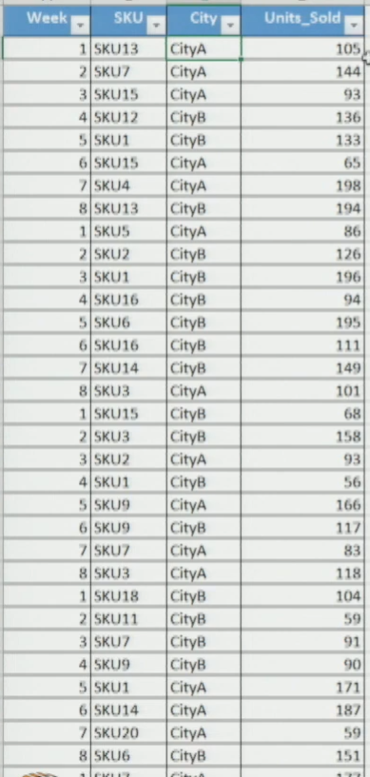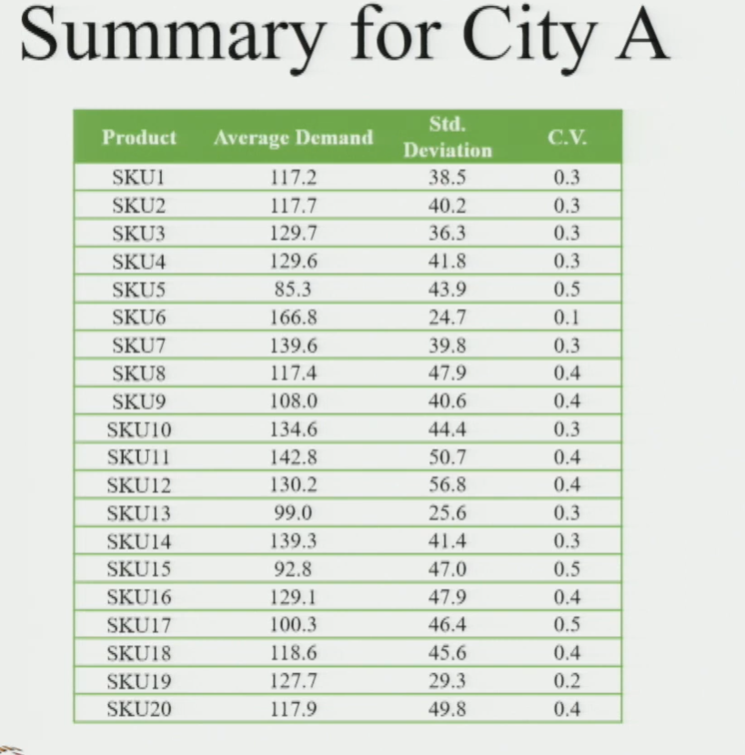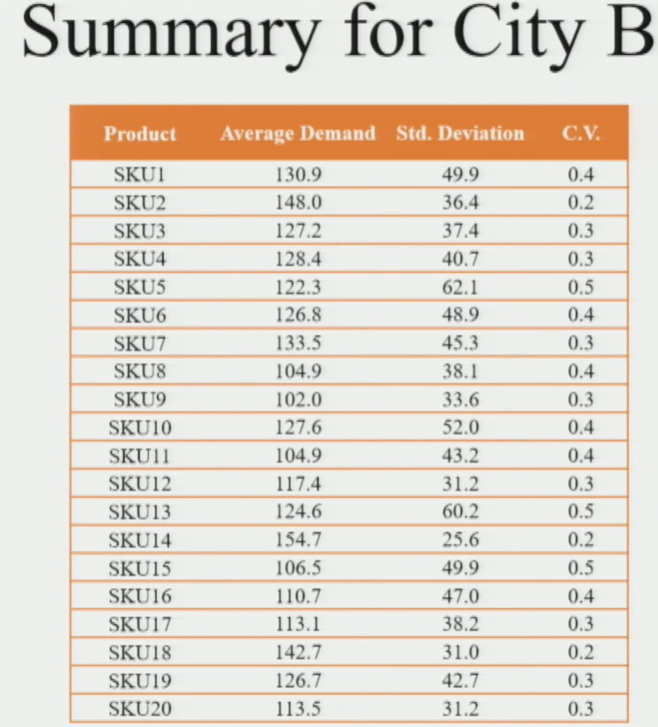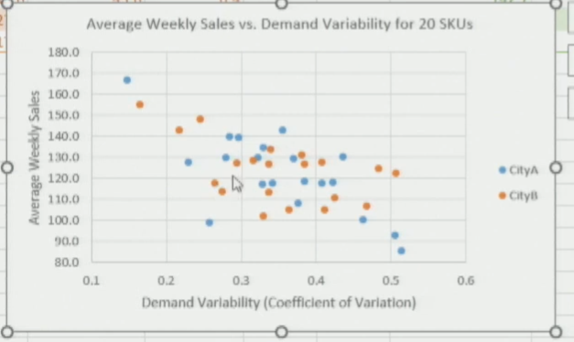
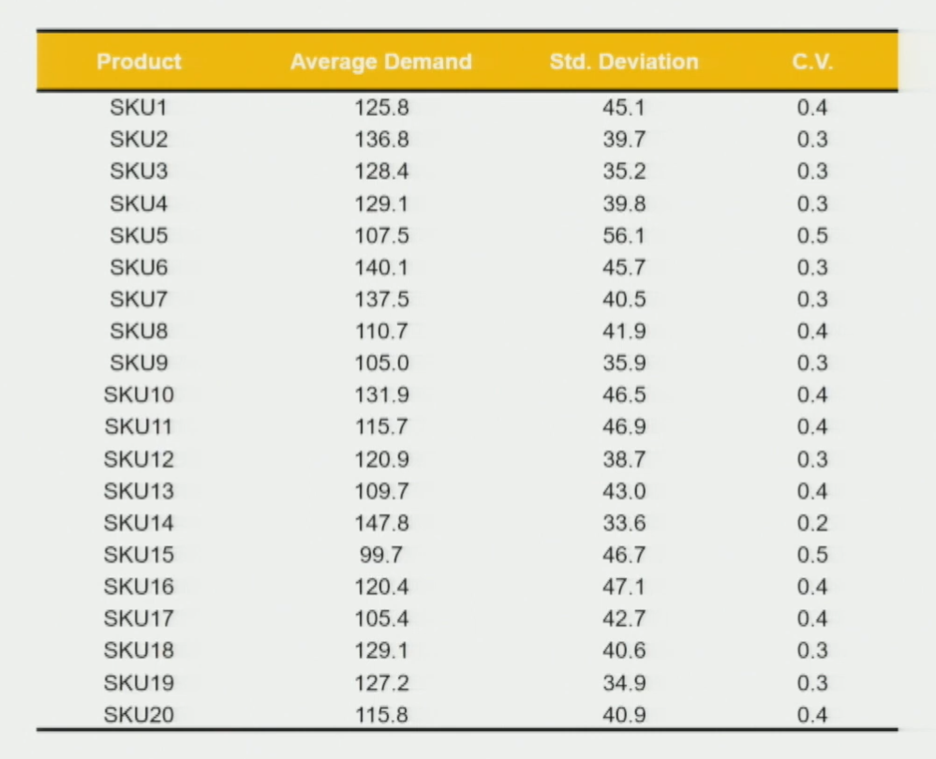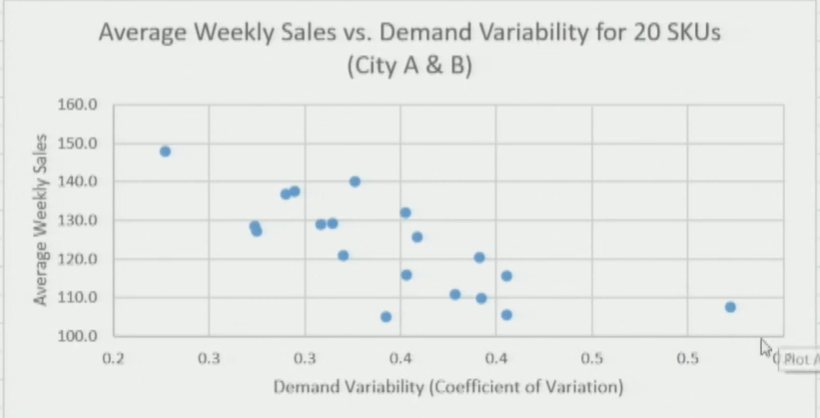
Scatter Plot Interpretation
- X-axis: CoV (Demand Variability) — low left, high right
- Y-axis: Average Weekly Sales — low bottom, high top
- Blue dots = City A SKUs, Orange dots = City B SKUs
- Key observation: Same SKU may have different CoV in different cities — demand pattern is city-specific
- Some SKUs: Low CoV + High sales → very stable, high volume
- Some SKUs: High CoV + Low sales → unpredictable, low volume
4-Quadrant Strategy Matrix
- Axes: X = Demand Variability (CoV), Y = Average Weekly Sales
- Divide the scatter into 4 quadrants based on a threshold for each axis
Quadrant 1 — Low CoV + High Sales (Top-Left)
- Product type: Essential / High-volume products
- Characteristics: Always in demand, stable, predictable
- Examples: Standard commodity goods, staple consumer products
- SC type: Efficient Supply Chain
- Strategy: PUSH — forecast-driven, mass production

Quadrant 2 — High CoV + Low Sales (Bottom-Right)
- Product type: Customized / Niche products
- Characteristics: Low demand volume + high unpredictability
- Examples: Special edition collectibles, highly customized products
- SC type: Responsive Supply Chain
- Strategy: PULL — demand-driven, high customization
Quadrant 3 — High CoV + High Sales (Top-Right)
- Product type: Consumer electronics / High-tech products
- Characteristics: High volume AND high variability — difficult to manage
- Examples: Consumer electronics, tech gadgets with rapid model changes
- Strategy: Hybrid Push-Pull
- Decide push-pull boundary based on level of customization required
- Refer to push-pull boundary framework from Session 3
Quadrant 4 — Low CoV + Low Sales (Bottom-Left)
- Product type: Basic / Slow-moving products
- Characteristics: Low sales + stable demand — neither high priority nor high risk
- Examples: Non-seasonal apparel basics, basic electronic components
- Strategy: Hybrid Push-Pull — combination decided based on specific product requirements
★ Quick recall: Q1 = Push (low CoV, high sales). Q2 = Pull (high CoV, low sales). Q3 & Q4 = Hybrid Push-Pull.
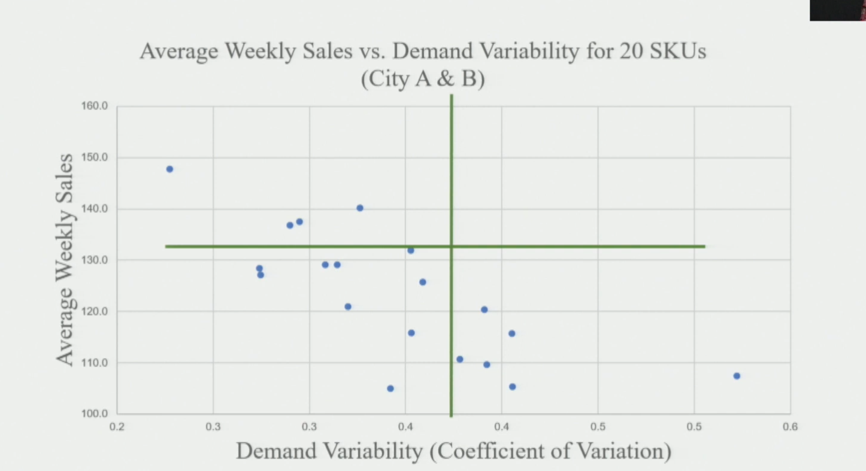
Part 2: Kraljic Matrix — Procurement / Sourcing Segmentation
Background
- Framework by: Peter Kraljic
- Purpose: Classify components/inputs required for manufacturing based on two factors
- Helps decide: Supplier relationship strategy + procurement approach for each component type
Two Axes of Kraljic Matrix
- X-axis: Supply Risk — factors include:
  - Availability of the component
  - Number of suppliers available
  - Competitive demand for the component
  - Make-or-buy feasibility
  - Any other supply-side risk factors
- Y-axis: Profit Impact — factors include:
  - Volume of the component required
  - Percentage of total purchase cost
  - Direct or indirect impact on business growth
4 Quadrants of the Kraljic Matrix
1. Non-Critical Items (Low Supply Risk + Low Profit Impact)
- Product is highly standardized
- Process is efficient; abundant supply — many suppliers available
- Easy to manage — multiple sourcing options exist
- Strategy: Streamline procurement, reduce admin effort, automate ordering
2. Leverage Items (Low Supply Risk + High Profit Impact)
- Abundant supply available, but high impact on profit
- Company has strong purchasing power — can negotiate hard
- Strategy: Exploit full purchasing power — competitive bidding, negotiate pricing aggressively
- Requires: Good pricing strategy
3. Strategic Items (High Supply Risk + High Profit Impact)
- Most critical category — high risk AND high profit impact
- Affects business on a long-term basis
- Strategy: Long-term supplier relationships + deep collaboration
- Cannot switch suppliers easily — partnership approach required
- Focus: Supply continuity, joint development, strategic alliances
4. Bottleneck Items (High Supply Risk + Low Profit Impact)
- High supply risk, but minimal impact on profit if unavailable
- However: Unavailability can disrupt operations even if profit impact is low
- Very low control over suppliers — difficult to manage
- Strategy: Ensure availability through safety stock / alternate sourcing; monitor closely
★ Exam tip: Kraljic matrix = sourcing strategy tool. Classify by Supply Risk (x) and Profit Impact (y). Four quadrants = Non-critical, Leverage, Strategic, Bottleneck.
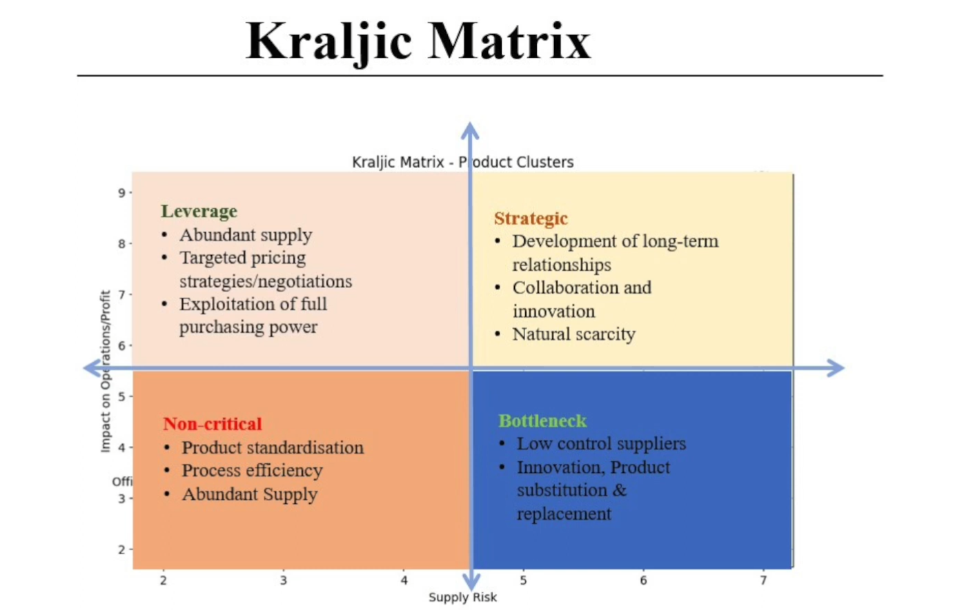
Kraljic Matrix — Quick Reference
- Non-Critical: Low risk + Low profit → Streamline, automate
- Leverage: Low risk + High profit → Negotiate hard, competitive bidding
- Strategic: High risk + High profit → Long-term partnerships, collaborate
- Bottleneck: High risk + Low profit → Secure supply, hold safety stock
Session Summary
- Two analytical product segmentation tools covered this session:
  - Tool 1 — Demand Variability vs Weekly Sales Quadrant:
    - Use CoV to measure demand variability across SKUs
    - Plot scatter (CoV vs avg weekly sales) → build 4-quadrant matrix
    - Q1: Push | Q2: Pull | Q3 & Q4: Hybrid Push-Pull
  - Tool 2 — Kraljic Matrix:
    - Classify components by Supply Risk + Profit Impact
    - Non-critical / Leverage / Strategic / Bottleneck → each needs different supplier strategy
★ Both frameworks are data-driven and practical — expect case-based questions in exams where you must classify SKUs or components and recommend SC strategies.

